EXPERIMENTNO11

Determination and plotting of Magnetic Flux density in Ferromagnetic Materials with different (i) length, (ii) width and (iii) magneticfieldintensity.

Aim:
To writeprogramfor Magneticflux density in ferromagneticmaterials usingSCILAB.

Softwarerequired:
•SCILABversion6.0.1

Program:

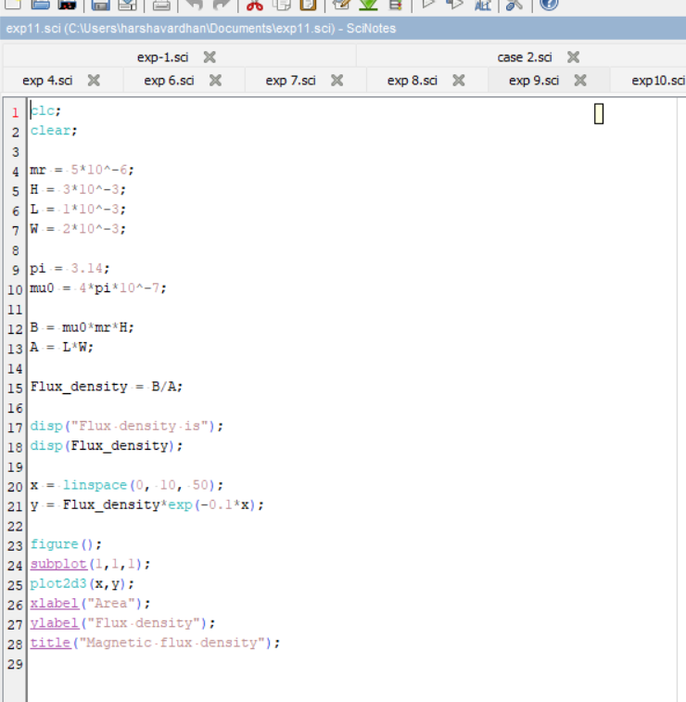

Output:

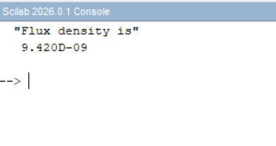

Theoreticalcalculations:

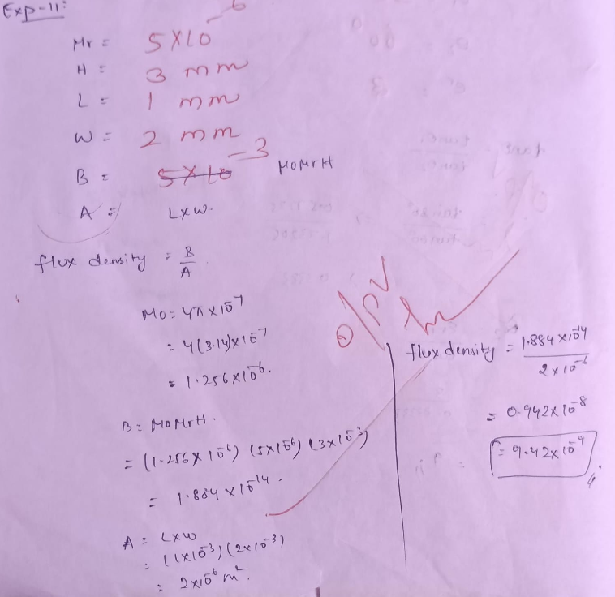

Case1:Examinetheeffectoflengthofaferromagneticmaterialon themagneticfluxdensity(B).

Analytical:
Calculatethemagneticfluxdensityforthefollowingconditions
- Thematerialisferromagneticwithrelativepermeability(μr)of500.
- Themagneticfieldintensity(H)isheldconstantat100A/m.
- Thelengthofthematerialvariesfrom0.1mto2m.

Program:
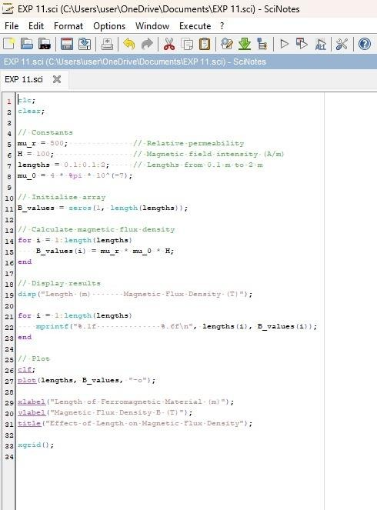

Output:

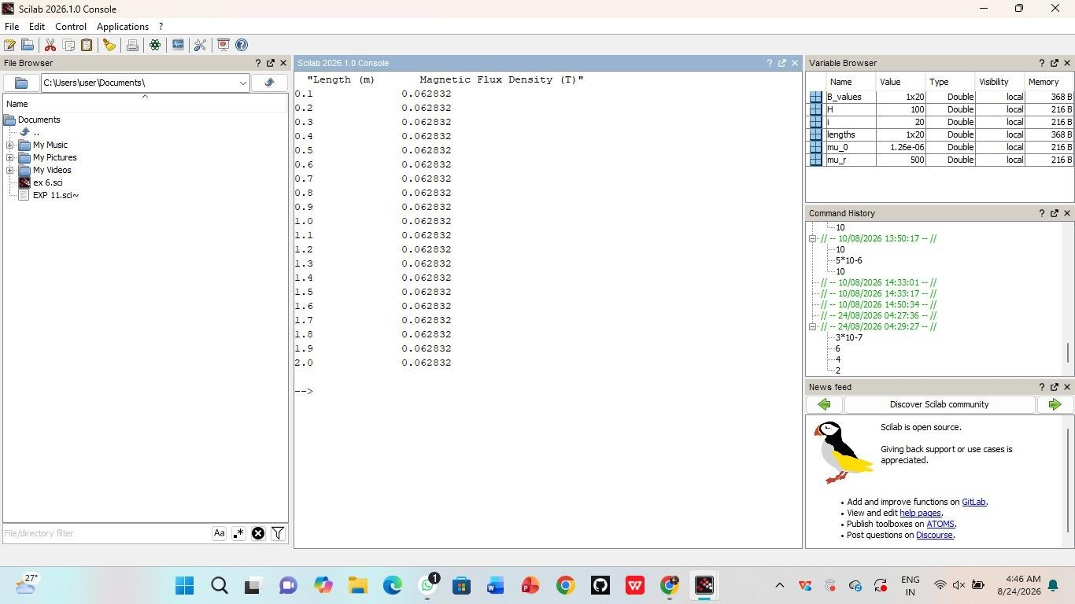

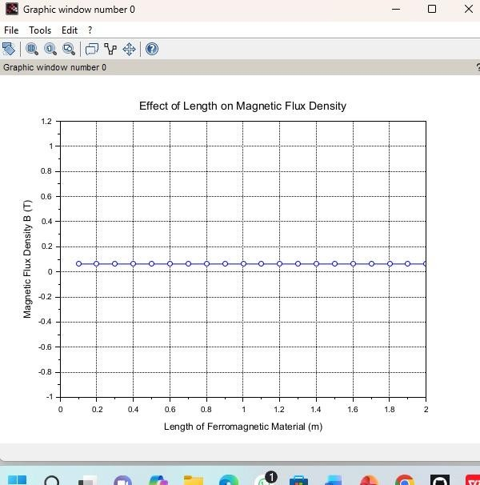
Case2:Toinvestigatehowthemagneticfluxdensity(B)ina ferromagneticmaterialchangeswith
Differentwidthsataconstantlengthandmagneticfieldintensity.

Analytical:
Calculatemagneticfluxdensity(B)inaferromagneticmaterial changeswithdifferentwidthsataconstantlength
Andmagneticfieldintensityforthefollowingcondtions
- Material:Softiron(sameasinCaseStudy1)
- Length(L):Constantat10cm
- MagneticFieldIntensity(H):Constantat1000A/m
- Width(W):Variesfrom2cmto10cm(i.e.,2cm,4cm,6cm,8cm,
10cm)

Program:
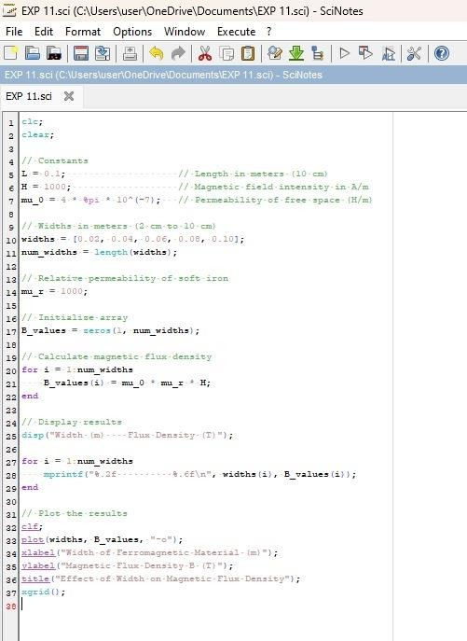

Output:

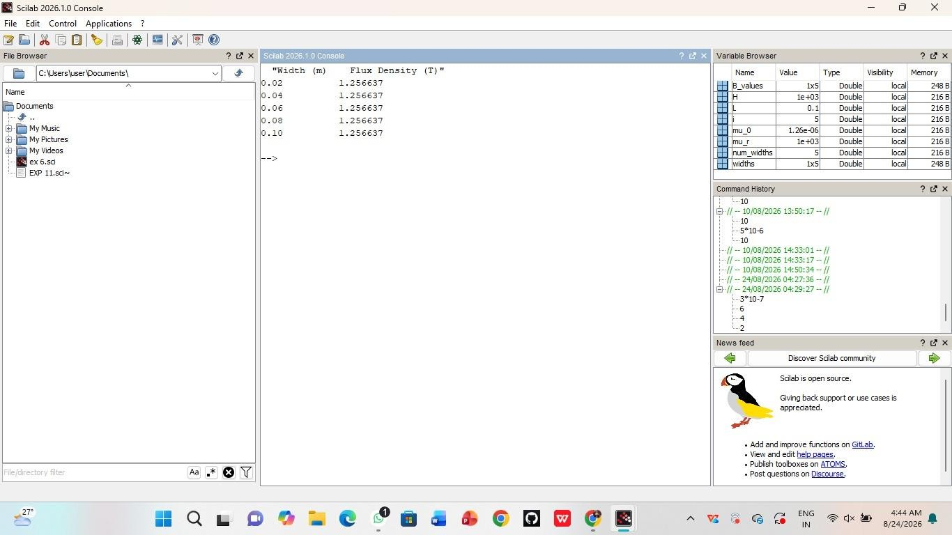


Case 3: To examine how the magnetic flux density (B) in a ferromagnetic material change with different values of magnetic field intensityatconstantlengthandwidth.

Program:
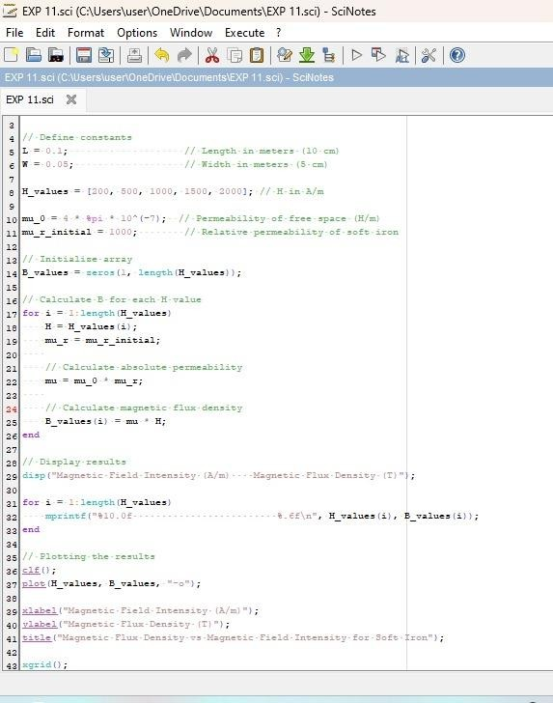

Output:
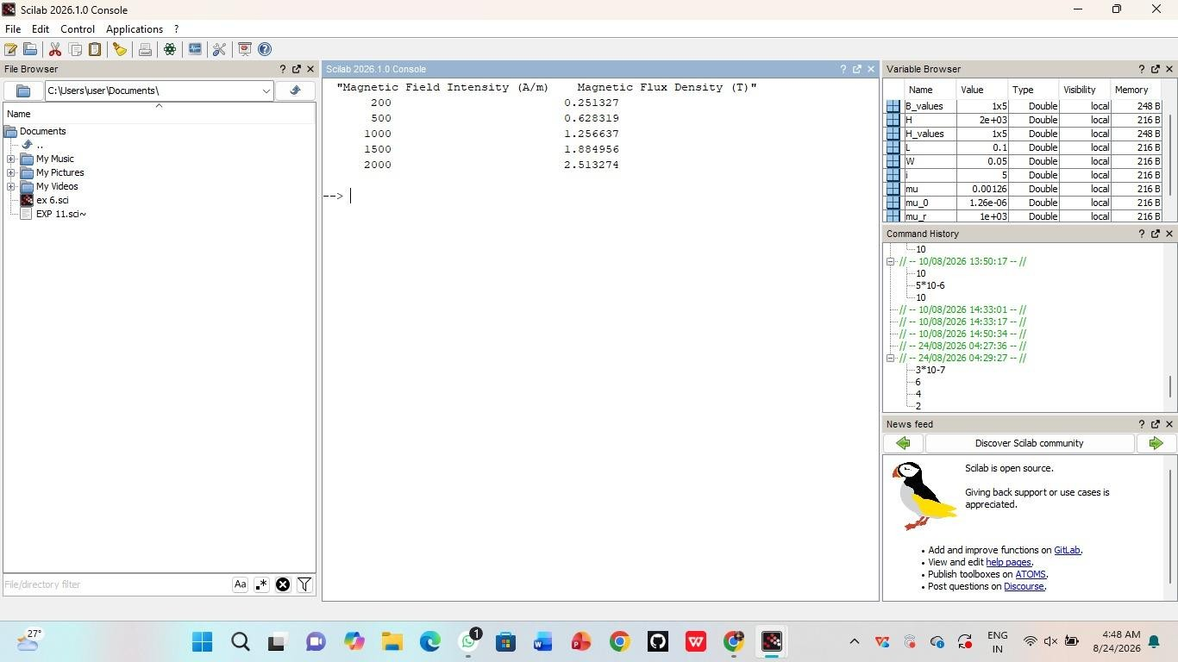

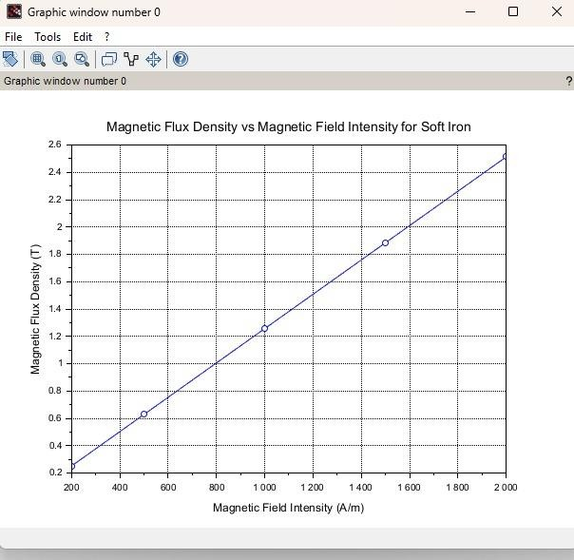

Result:
TheeffectofMagneticfieldintensityofaferromagneticmaterialon themagneticfluxdensity(B)isexamined.

